Computer Language Coding Concepts

Miscellaneous Inheritance Situations
This article shows a couple of miscellaneous situations that can occur when you work with inheritance.

Command Inheritance
Because commands are just objects, inheritance can also be used between commands. One command can class-inherit from another command:

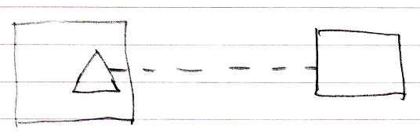

Object and interface inheritance is also possible for commands:

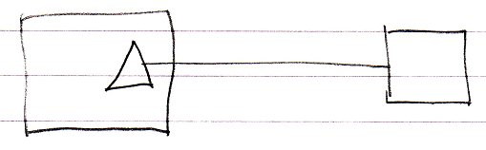

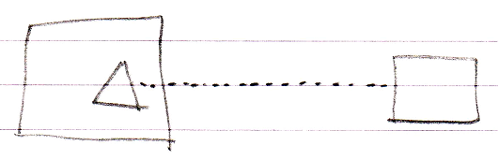

Since commands are just objects that can be executed, a command could in theory also inherit from an object:

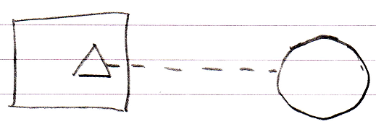

Backward Relation to Derived Classes
Due to the duality of relationships, when a derived class can point out its base class, the base class could also point back at the derived class.

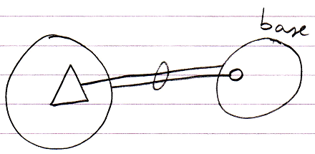

Or for class inheritance:

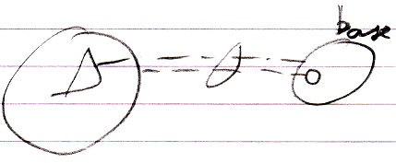

Multiple Objects Sharing one Base Object
Because multiple objects can inherit from the same instance of an object, you can have a set of objects use another object as their base:

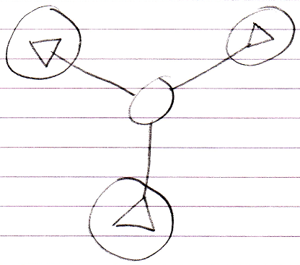

Author & Copyright: Jan-Joost van Zon Date: May 23, 2010 – May 23, 2010 Location: Oosterhout, The Netherlands Status: Finished

